Silent Auction – No. 4  Baby Blanket - Needlepoint  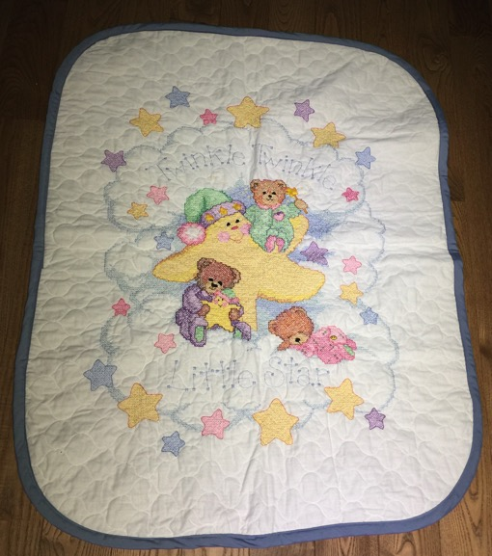 | Silent Auction – No. 8  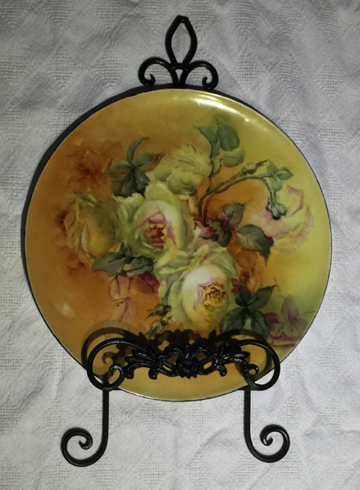  Ceramic Plate with Wall Hanger
Silent Auction – No. 10  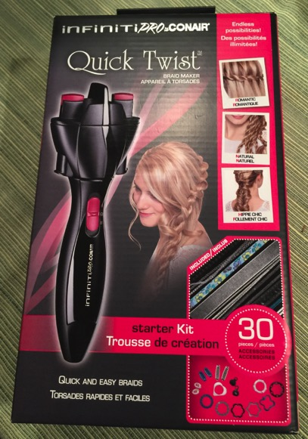  Conair Infiniti Pro-Braid Maker | Silent Auction – No.11  Decorator Items – Egyptian Theme  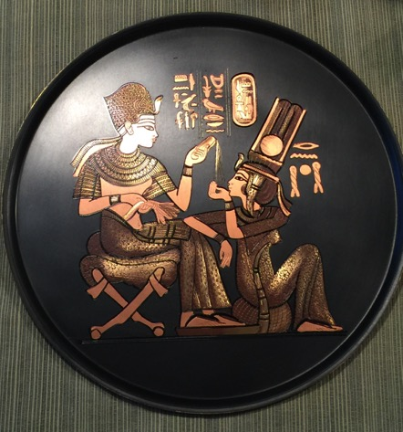  Item Shown is 1of 4
Silent Auction – No. 18  Flower Arrangement  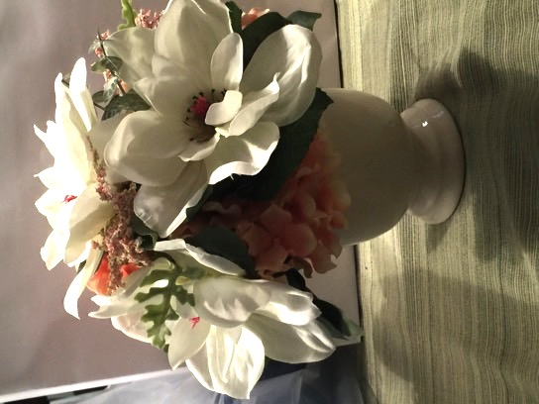 | Silent Auction – No. 28  Jams and Chutneys Gift Basket  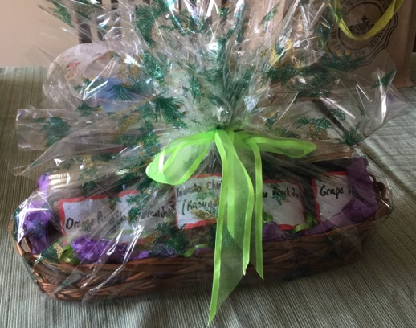
Silent Auction – No. 32  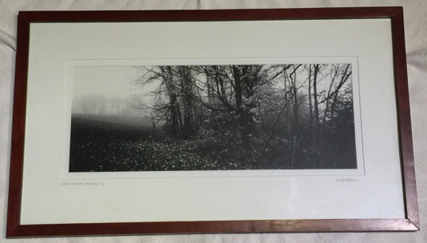  Landscape Print by D. Bartholomew | Silent Auction – No. 33  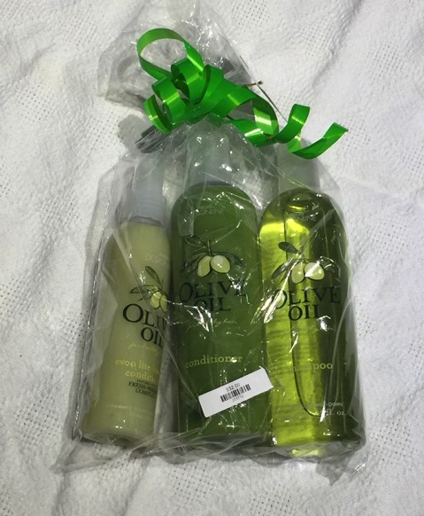  Magicuts Hair Products
Silent Auction – No. 38  Maesto 2006 Ford Harley-Davidson  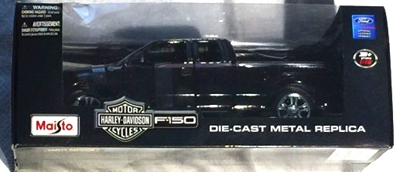  F-150 Model 1:18 | Silent Auction – No. 39  Highway 61 Chevy Fleetside Pickup  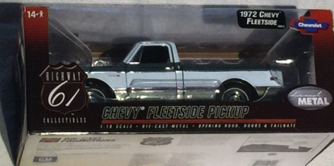  Model 1:18
Silent Auction – No. 40  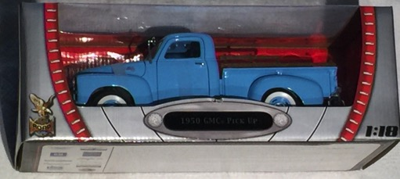  Road Signature 1950 GMC Pick Up Blue Model 1:18 | Silent Auction – No. 46  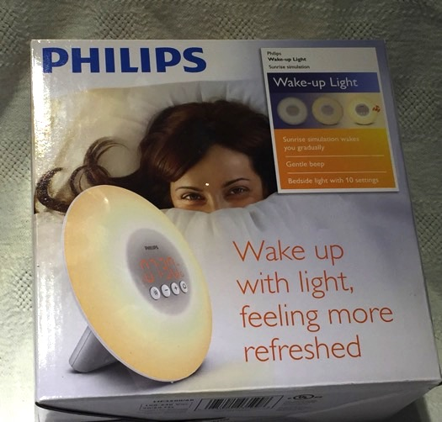  Philips Wake Up Light
Silent Auction – No. 48  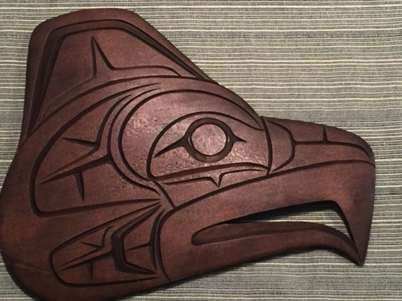  Plaque, Hand Carved, Eagle | Silent Auction – No. 49  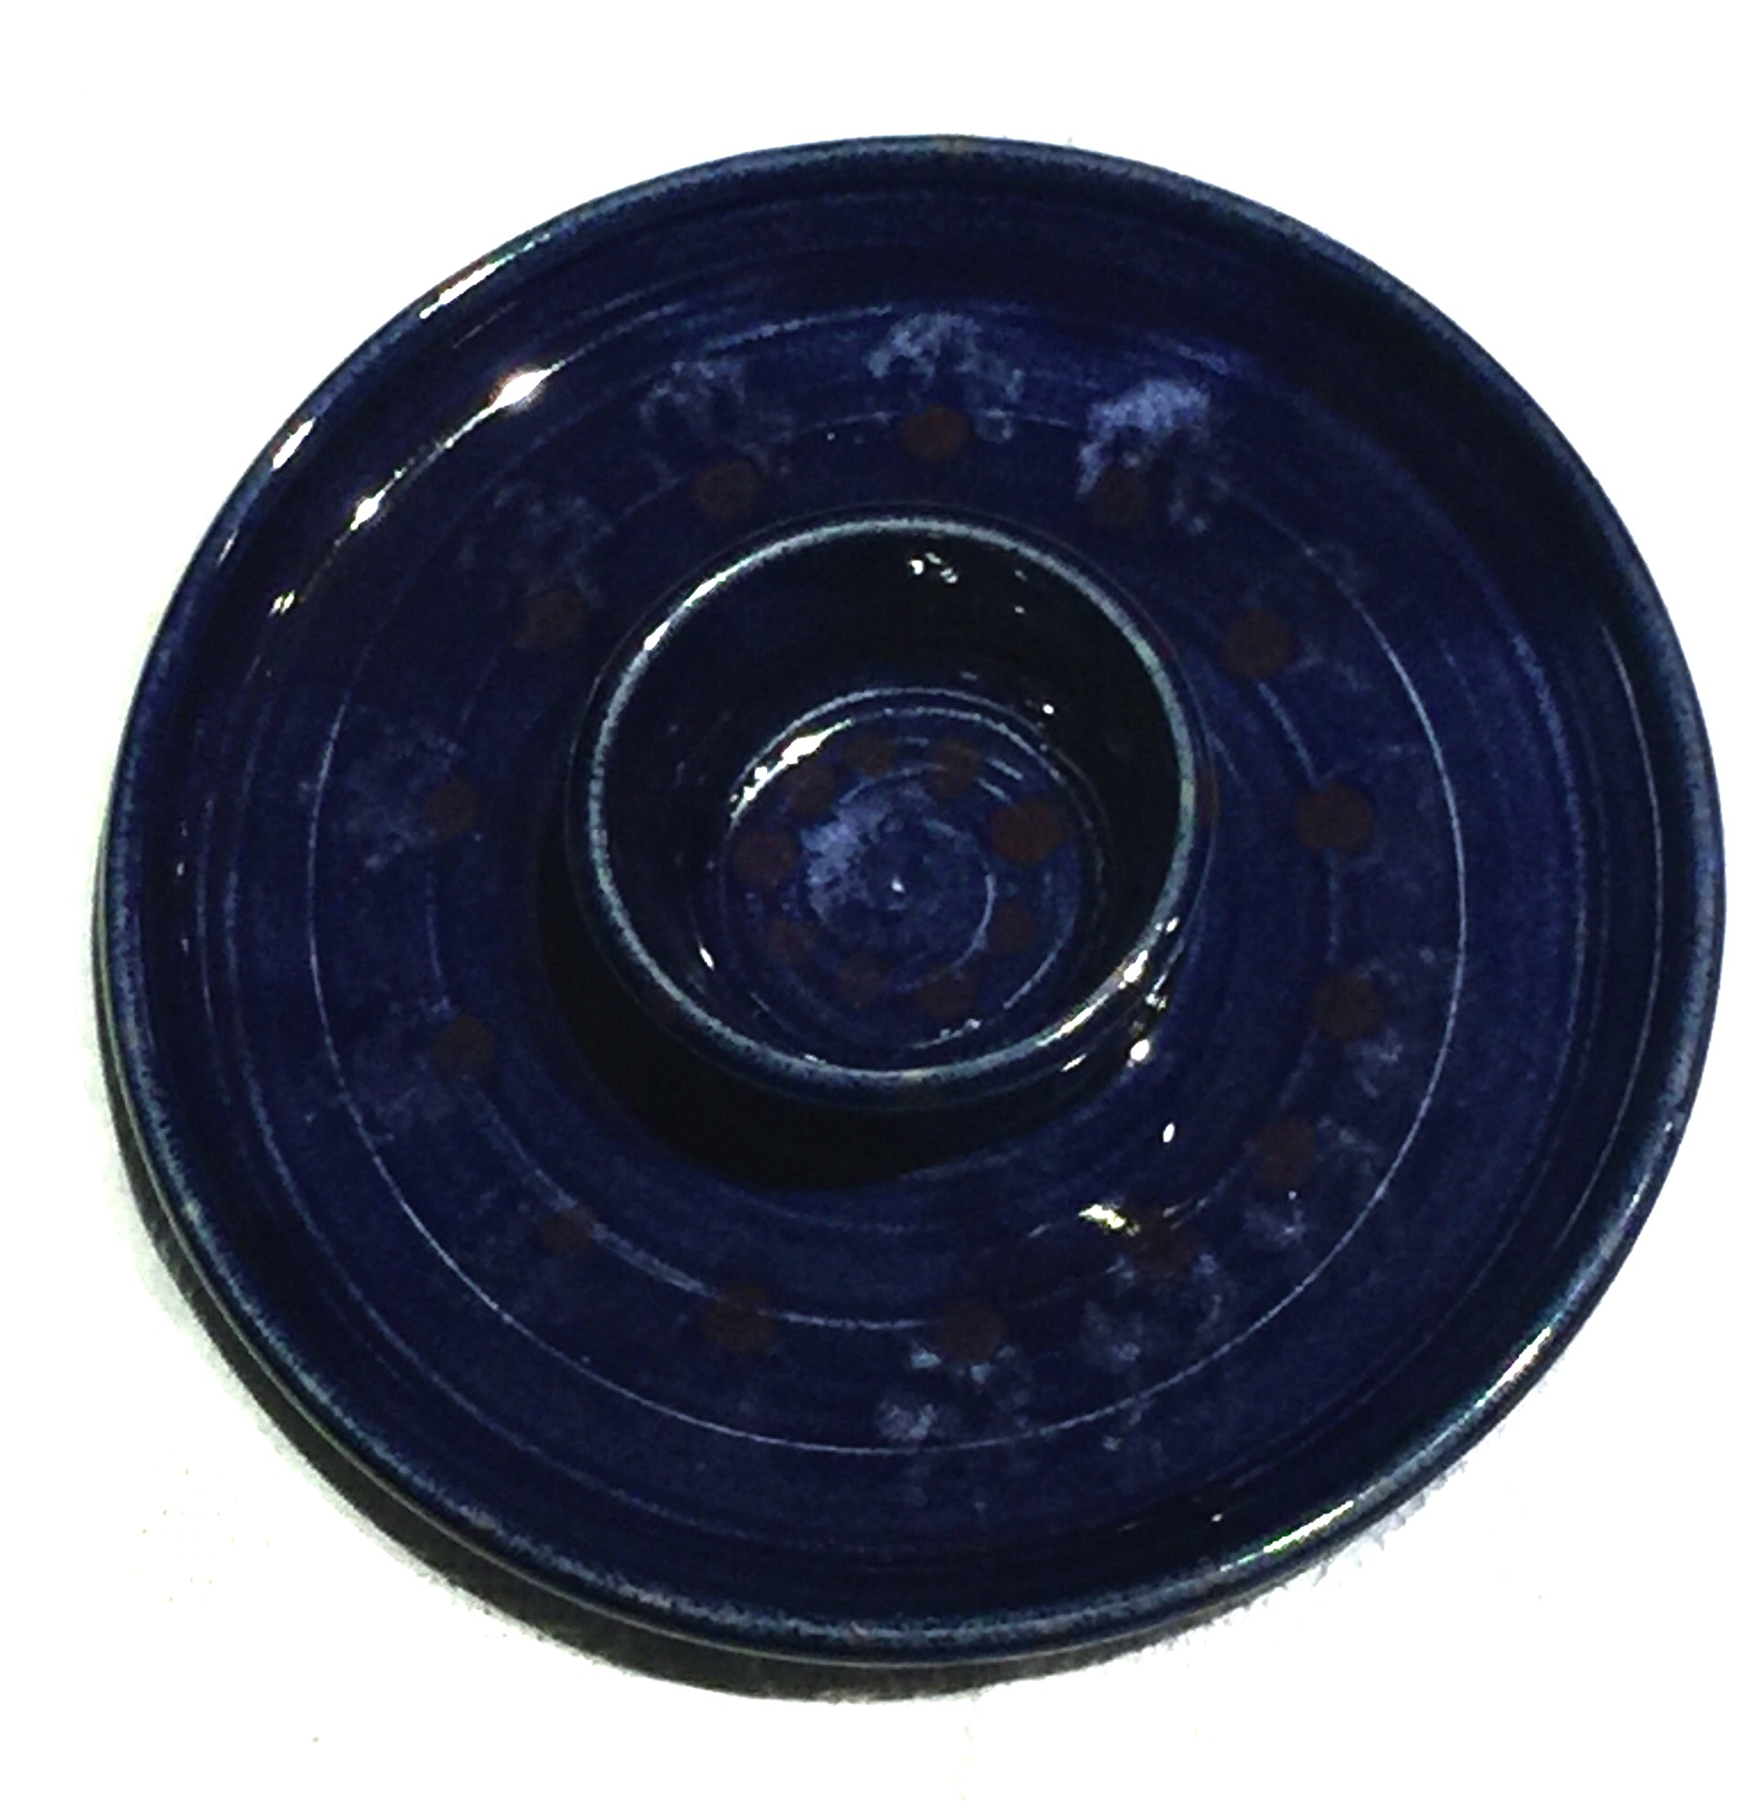  Pottery – Dip Tray
Silent Auction – No. 50  Pottery – Serving Platter  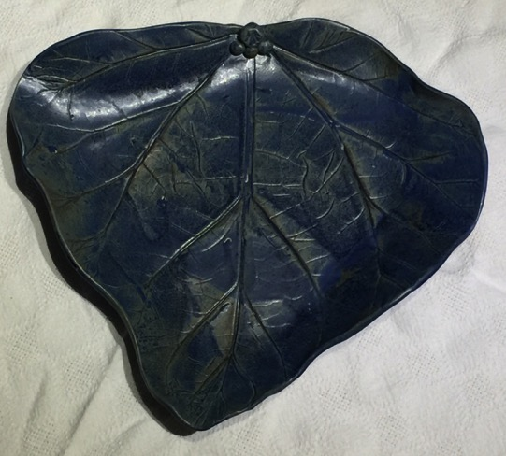 | Silent Auction – No. 51  Purse, Kate Spade Designer  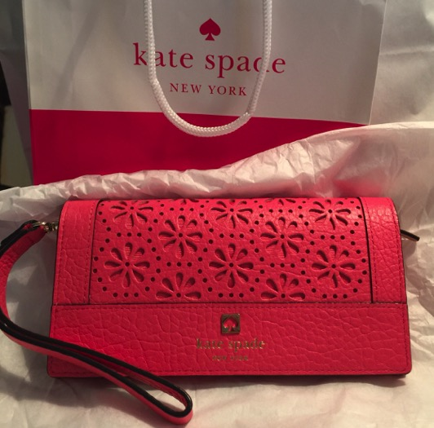
Silent Auction – No. 52  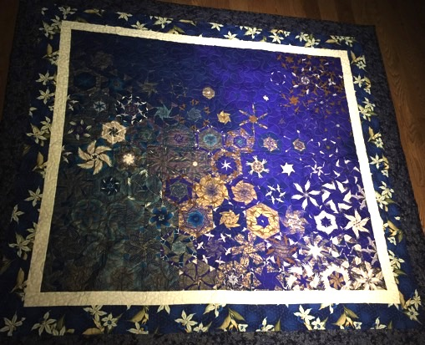  Quilt/Wall Hanging - Blues | Silent Auction – No. 53  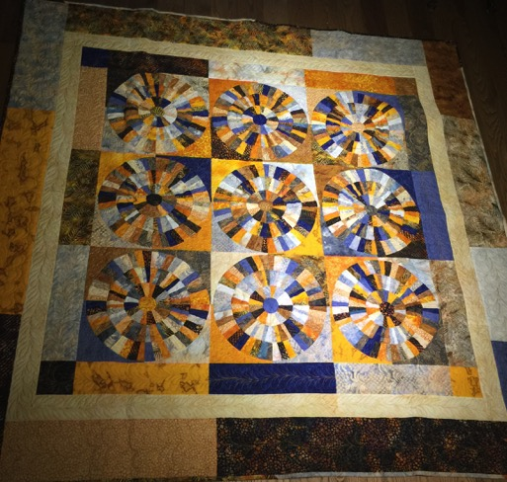  Quilt/Wall Hanging – Golds
Silent Auction – No 54  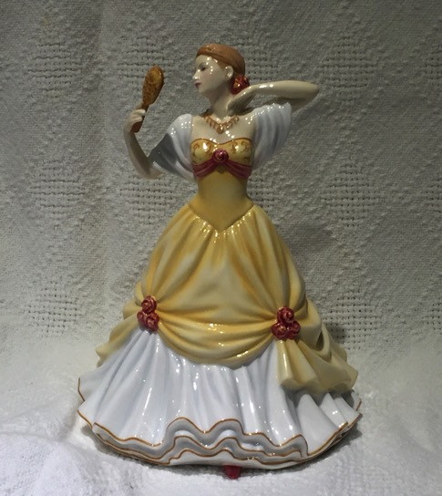  Royal Doulton Figurine - Lauren | Silent Auction – No. 55  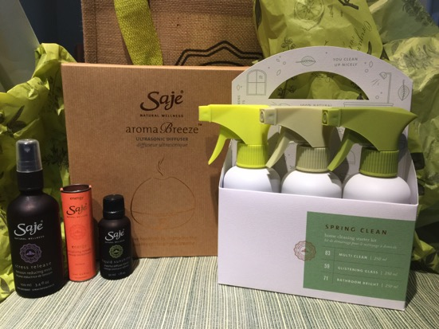  Sage Natural Wellness – Products
Silent Auction – No. 56  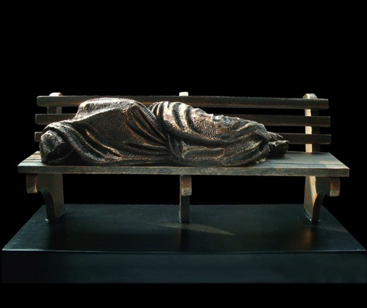  Schmalz Figurine  Homeless Jesus | Silent Auction – No. 57  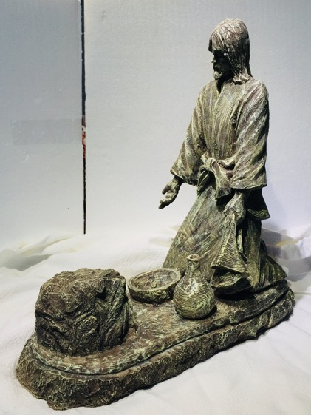  Schmalz Figurine  He Comes To Serve
Silent Auction – No. 58  Schmalz Figurine  A Quiet Moment  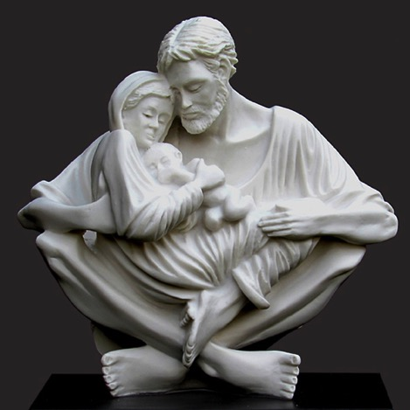 | Silent Auction – No. 59  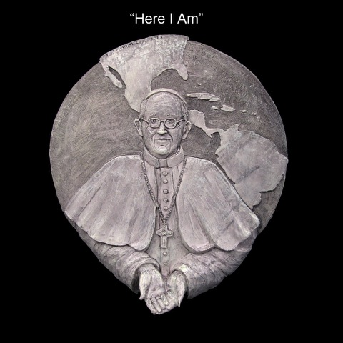  Schmalz Figurine – Wall Relief  Here I Am
Silent Auction – No. 60  Schmalz Figurine  Last Supper  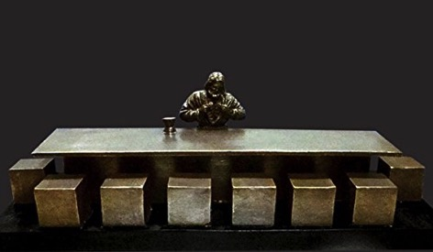 | Silent Auction – No. 61  Schmalz Figurine  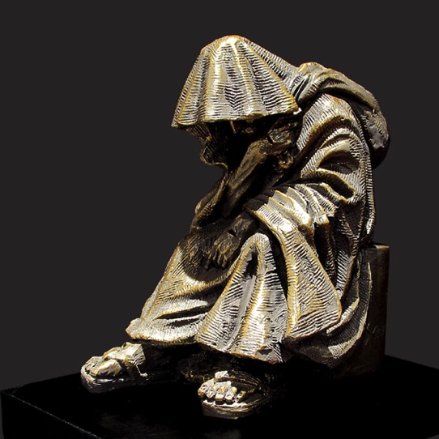  When I Was a Stranger
Silent Auction – No. 64  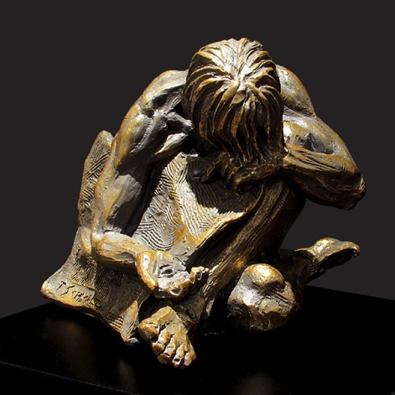  Schmalz Figurine  When I Was Naked | Silent Auction – No. 65  Schmalz Figurine  When I Was Sick  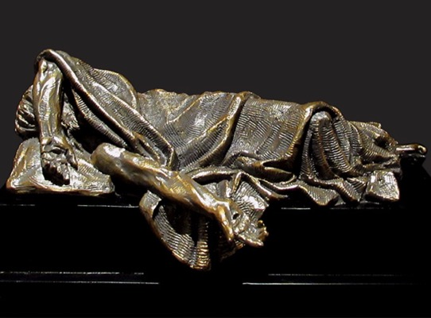
Silent Auction – No. 62  Schmalz – When I Hungry and Thirsty  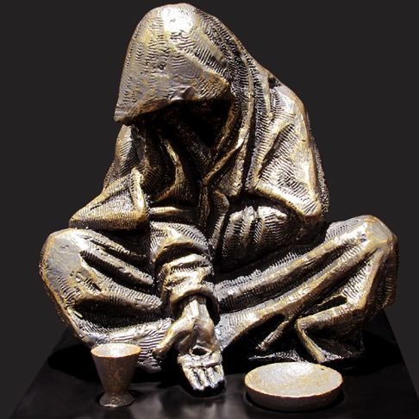 | Silent Auction – No. 63  Schmalz – When I Was in Prison  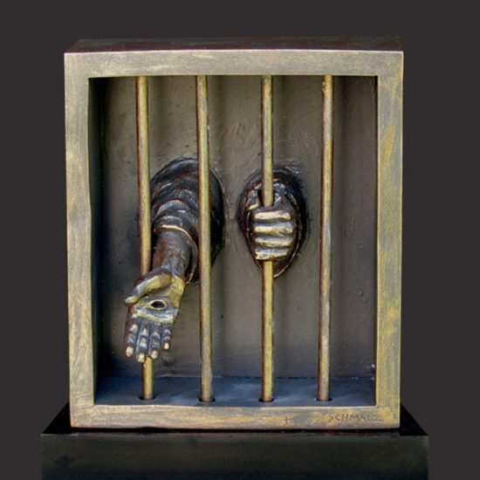
Silent Auction – No. 66  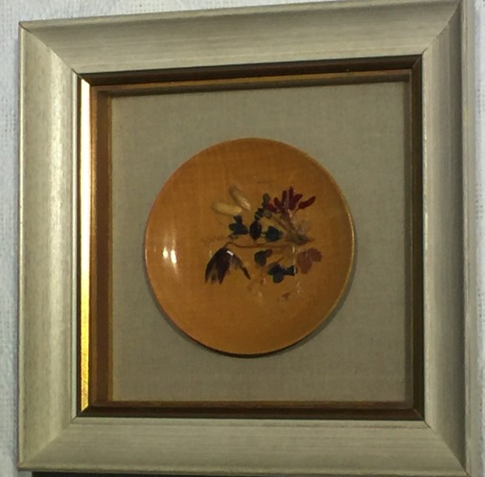  Shadow Box - Wooden Bowl | Silent Auction – No. 67  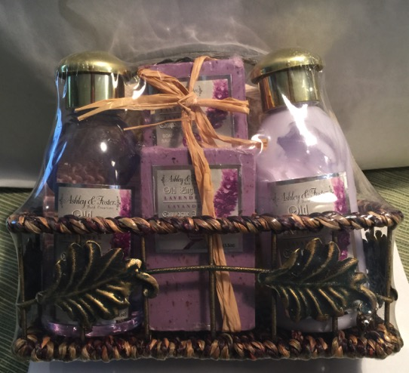  Soaps and Lotions
Silent Auction – No. 74  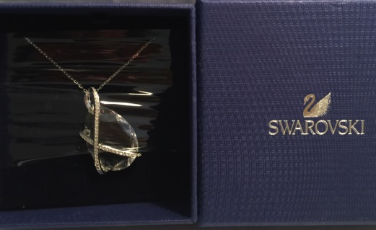  Swarovski Necklace/Pendant | Silent Auction – No. 75  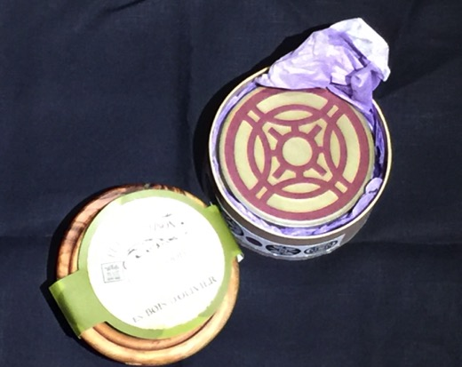  Table Runner (Black), Coasters and Nested Wooden Bowls
Silent Auction – No. 76  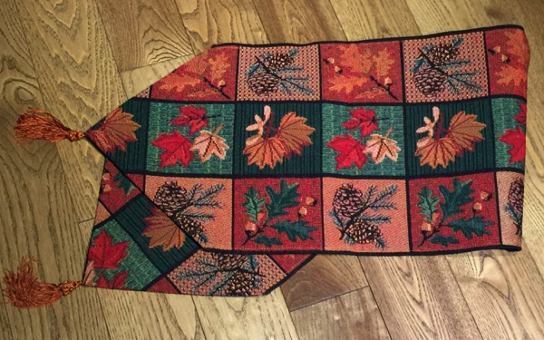  Table Runner – Fall Colours | Silent Auction – No. 77  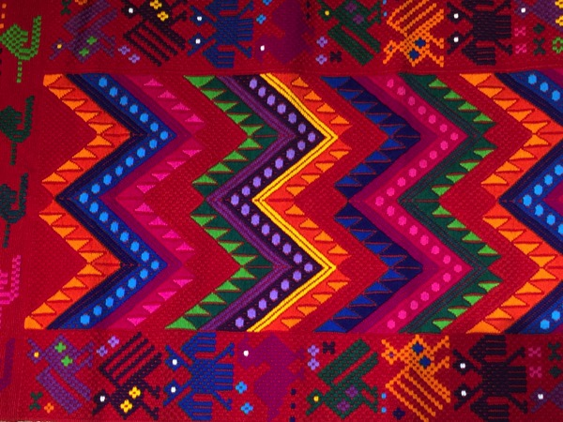  Table Runner – From Guatemala
Silent Auction – No. 78  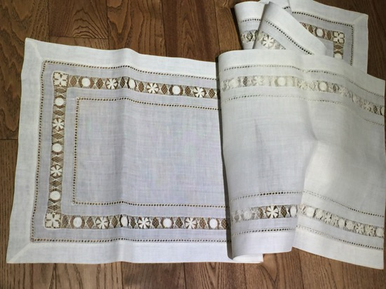  Table Runner – Linen, Cream Colour | Silent Auction – No. 79  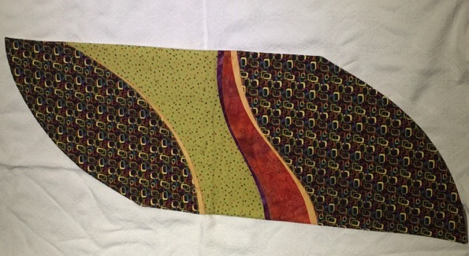  Table Runner – Wavy Lines
Silent Auction – No. 80  Teas (Assorted) with Infuser Mug  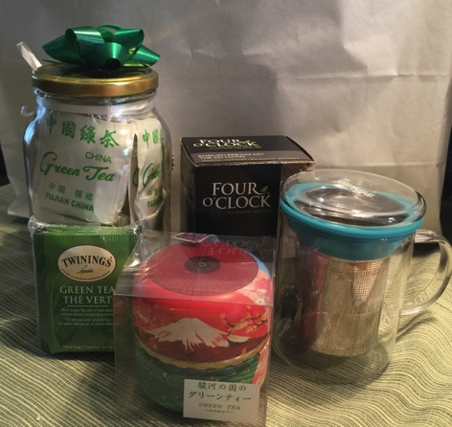 | Silent Auction – No. 83  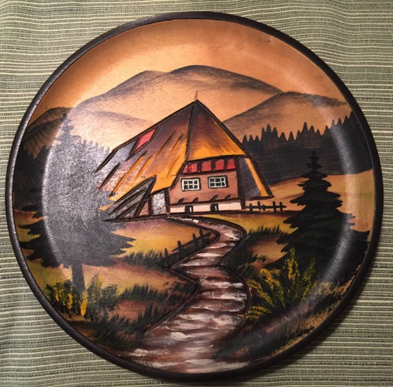  Wall Plaque, Wood, Mountain Scene
Silent Auction – No. 84
Wall Plaque and Bracelet
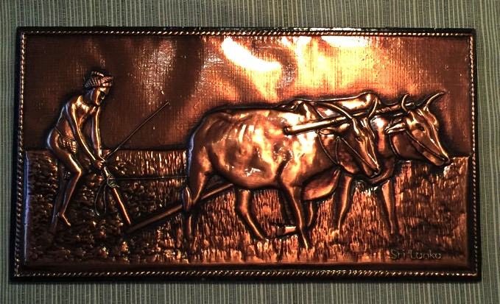
Copper – from Sri Lanka

